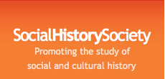 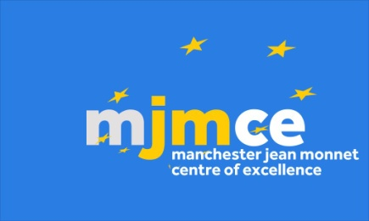 

**Transnational Cultures of Petitioning symposium**

**University of Manchester**

**Organized by the Cultures of Politics Research Group, History Division.**

**The organizer would like to gratefully acknowledge the support of the Social History Society, the Manchester Jean Monnet Centre of Excellence and the History Division, University of Manchester.**

**Register** via this link (£10 fee for catering - waived for postgraduates; optional dinner @ £20)

[https://estore.manchester.ac.uk/browse/product.asp?compid=1&modid=2&catid=440](https://outlook.manchester.ac.uk/owa/redir.aspx?SURL=eN-5LWfvgQOOQ2og8r86vhpnTKlChuCMsZZ-8o-p7CDWEk41GWvSCGgAdAB0AHAAcwA6AC8ALwBlAHMAdABvAHIAZQAuAG0AYQBuAGMAaABlAHMAdABlAHIALgBhAGMALgB1AGsALwBiAHIAbwB3AHMAZQAvAHAAcgBvAGQAdQBjAHQALgBhAHMAcAA_AGMAbwBtAHAAaQBkAD0AMQAmAG0AbwBkAGkAZAA9ADIAJgBjAGEAdABpAGQAPQA0ADQAMAA.&URL=https%3a%2f%2festore.manchester.ac.uk%2fbrowse%2fproduct.asp%3fcompid%3d1%26modid%3d2%26catid%3d440)

**Website:** <https://transnationalpetitioning.wordpress.com>

**Monday, 29 June**

Roscoe Building, 1.001

Registration and welcome

11-11.30am Registration and welcome

11.30-1pm Panel 1: Petitions in Transnational and National Contexts

Prof. Daniel Carpenter (Harvard): Recruitment by Petition: American Antislavery, French Protestantism, English Suppression

Dr. Maartje Janse (Leiden): “The King had Never Received a Petition Like this One”: Dutch 19th Century Petitioning Practices in Transnational Perspective

Dr. Henry Miller (Manchester): Democracy, Representation and Petitioning in the Long 19th Century

1-1.45pm Lunch

1.45-3.15pm Panel 2: Local Cultures of Petitioning

Dr. Richard Huzzey (Liverpool): Abolition, Petitioning and Prosopography in Plymouth

Sami Pinabarsi (Manchester): Manchester and its Anti-Slavery Petitions, 1787-1806

Dr. Robert Poole (University of Central Lancashire): The Lancashire petitions for parliamentary reform, 1816-17

3.15-45pm: Refreshments

3.45-5.15pm Panel 3: Petitioning in the Age of Revolutions

Dr. Diego Palacios Cerezales (Stirling): Petitioning and Revolution in Spain, 1808-68

Dr. Michelle Orihel (Southern Utah University): Kentucky Jacobins?: Transatlantic Republicanism and Western Remonstrances to the Washington Administration, c. 1793-94

Dr. Yann-Arzel Durelle-Marc (Université Paris 13): Constancy and Difference in Petitioning in Revolutions in the Atlantic World, 17-19th Century

5.15-6.15pm

Keynote, room tbc

Prof. David Zaret (Indiana): Petition and Response in Pre-Modern Eurasia

7.30pm

Dinner, Evuna, Deansgate

**Tuesday, 30 June**

Simon Building, 4A/4.63 (subject to change)

9.45am Refreshments

10-11.30am Panel 4: Petitioning and the Languages of Identity

Prof. James Jaffe (University of Wisconsin-Whitewater): The Languages of Petitioning in Colonial India

Prof. Mark Knights (Warwick): Was There a Right to Petition?

Dr. Benoit Agnes (Université Paris 1 Panthéon-Sorbonne): Shaping Feminine Identity through Female Petitions: An Anglo-French Comparison, 1814-48

11.30-12 Refreshments

12-1pm Panel 5: Roundtable: Future Directions for Research

Prof. Daniel Carpenter (Harvard)

Prof. Malcolm Chase (Leeds)

Prof. Mark Knights (Warwick)

Prof. David Zaret (Indiana)

Chair: Dr. Henry Miller (Manchester)

1-2pm Lunch

End

Any queries please email Henry Miller at [henry.miller@manchester.ac.uk](mailto:henry.miller@manchester.ac.uk)