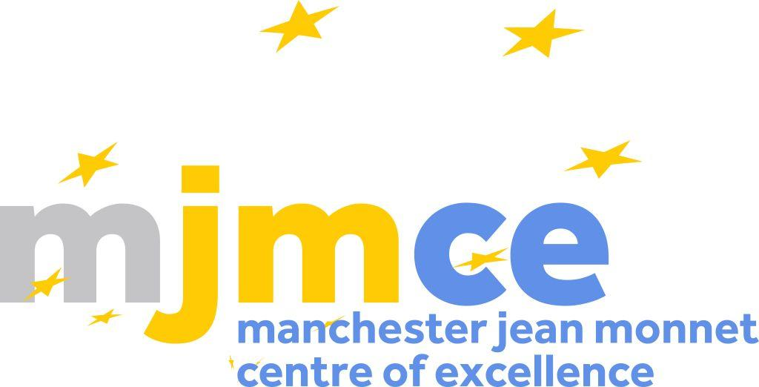

The Manchester Jean Monnet Centre of Excellence
Annual Review of Activities, 2024-2025
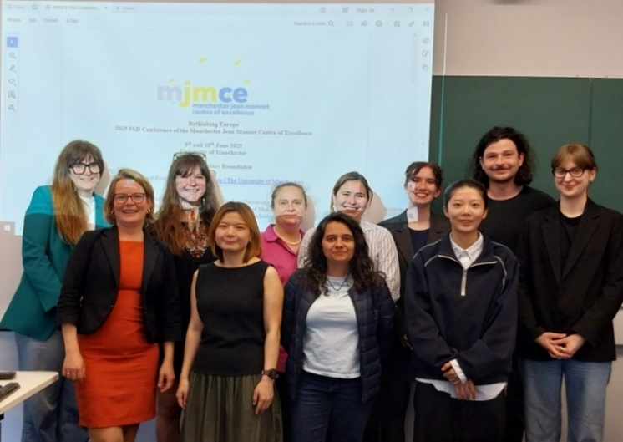
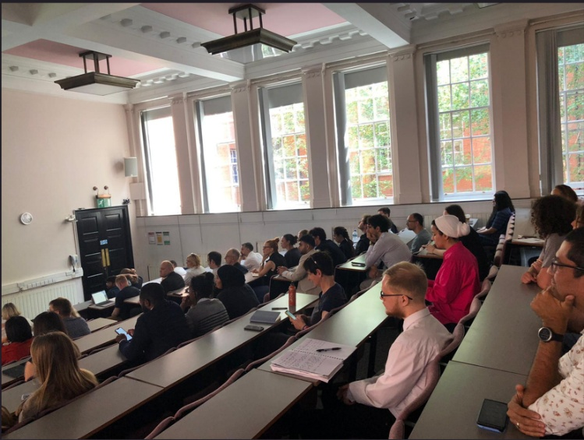
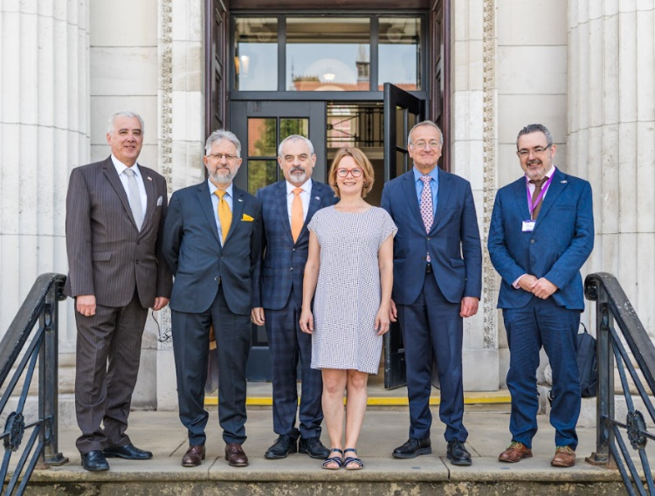
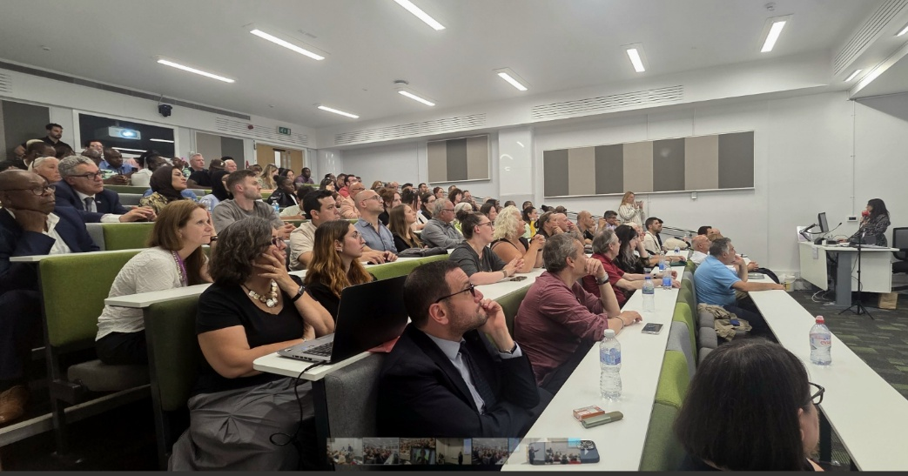

July 2025
- Introduction
The Manchester Jean Monnet Centre of Excellence (MJMCE) provides a platform for European Studies-related research in Greater Manchester and the North West of England, with partners from the University of Manchester, Manchester Metropolitan University and the Europe in the World Centre at the University of Liverpool.
The Centre aims to strengthen the intellectual community in European Studies, while also facilitating local, regional and international links with practitioners, researchers, students and others interested in European affairs. Initially created in 2003 with the financial support of the European Commission under its Jean Monnet Action and co-funded by the University of Manchester, the MJMCE relies on subscriptions from its principal stakeholders for its operation and is grateful for their continuing support.
The following pages report specifically on the structure and achievements of the Centre during the academic year 2024-25. The JMCE has had an eventful year of animating our trans-disciplinary research network and connecting research communities across Manchester, the North of England, Europe and beyond. We organised a well-attended event and seminar series with internationally recognised and world leading speakers across all of member institutions. In doing so, we also cooperated with centres and research networks across our Universities. We also supported teaching and research across all member institutions with staff and student bursaries and awards. Highlights of the year included a seminar by the first ever laureate of the JCME Doctoral Dissertation Prize; the JMCE PhD Conference which brought together a wide range of PGRs and colleagues from Manchester, Liverpool and beyond for a two-day event featuring a publishing roundtable and paper workshops; as well as our annual lecture organised as a Roundtable with support from the European Union Delegation in the UK. On 10 July 2025, we were pleased to welcome EU Ambassador Pedro Serrano to the JMCE, as well as high-level diplomats of Cyprus, Malta and Slovakia to a packed Sam Alex Lecture Hall.
In the coming academic year, we look forward to welcoming the Alliance Manchester Business School into our network. We will continue to focus on generating a vibrant research environment for European Studies at all member institutions and by continuing our public and policy outreach. We plan to cooperate with other research networks, institutes and centres, for example in hosting a joint research seminar with the Manchester Political Economy Centre, welcoming Hallsworth Visiting Professor Stefanie Wöhl from Vienna. As 2024/25 was the first year in which we received more bursary applications from staff and students than we could fund, we will review our allocation criteria in order to assist us in identifying the projects that are most closely aligned with the JMCE mission.
With new board members from business studies joining and invigorating our work, our strategy remains to promote European Studies in Manchester and the UK, and to promote the standing of Manchester and UK-based researchers in the field of European Studies. As the Director of the Centre, I would be delighted /to receive your thoughts and feedback on our activities, past, present and future! I also wish to thank personally all of our stakeholders for supporting the work of the JMCE over the years!

Dr. Silke Trommer
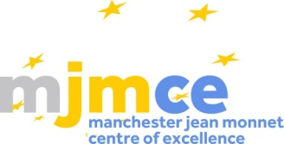
Director of the Manchester Jean Monnet Centre of Excellence
- Stakeholders
The Manchester Jean Monnet Centre of Excellence showcases European expertise across the main Universities of the city a. Its principal stakeholders are:
- The University of Manchester
  - School of Arts, Languages and Cultures
  - School of Social Sciences
- Manchester Metropolitan University
  - Department of History, Politics and Philosophy
- The University of Liverpool
  - Europe in the World Centre

- The JMCE Board

The JMCE Board sets and approves the JMCE budget as well as the priorities of the Centre. We met three times in the academic year 2024/25. Our board members are:

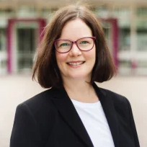
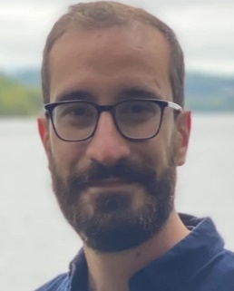

Dr. Silke Trommer, Director (UoM)
Dr. Davide Schmid,
Deputy Director (MMU)
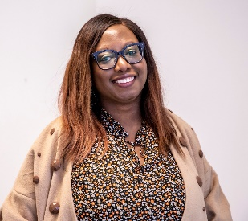
Prof. Erika Harris,
Board Member (EWC, UoL)
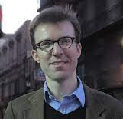


Prof. Toni Haastrup,
Board Member (UoM)
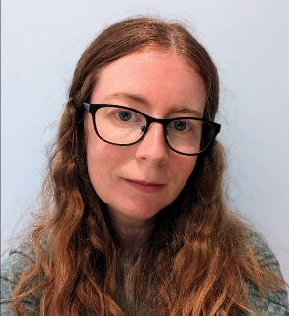
Prof. Christian Goeschel,
Board Member (UoM)
Dr. Eleanor Bindman,
Board Member (MMU)

Dr. Eleanor Aspey,
Board Member (UoM)
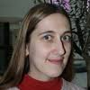
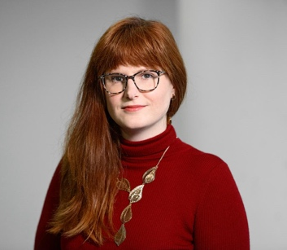
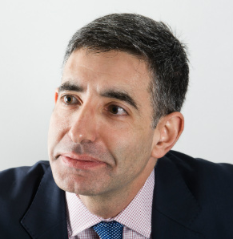

Dr. Olga Krushcheva,
Board Member (MMU)
Dr. Dimitrios Doukas,
Board Member (UoM)
Dr Gemma Bird,
Board Member (EWC, UoL)
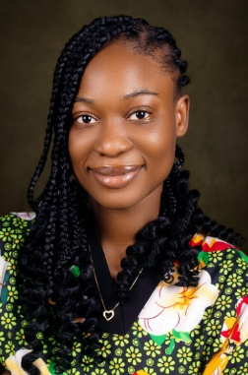
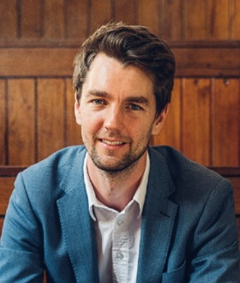
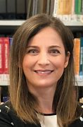

Nelly-Helen Ebruka,
MJMCE Administrator (UoM)
Dr. Paul Tobin,
Board Member (UoM)
Dr. Rahime Süleymanoğlu Kürüm,
Board Member (MMU)

- Review of Activities

  - JMCE Seminar Series

This academic year, our seminar series covered a wide range of fields of inquiry in line with the multidisciplinary tradition of the Centre and our mission to strengthen the intellectual community in European Studies across Manchester and the North of England. We hosted seminars at all member institutions and made available travel funding for students attending Manchester seminars from Liverpool and vice-versa.

Our research talks covered a EU policy areas (trade, security, climate change), disciplinary engagements with Europe (history, sociology, political economy, international relations, politics, feminism, racial studies), and thematic focal points addressing current debates (nationalism, imperialism, EU-UK relations, EU in the world, the War on Ukraine).

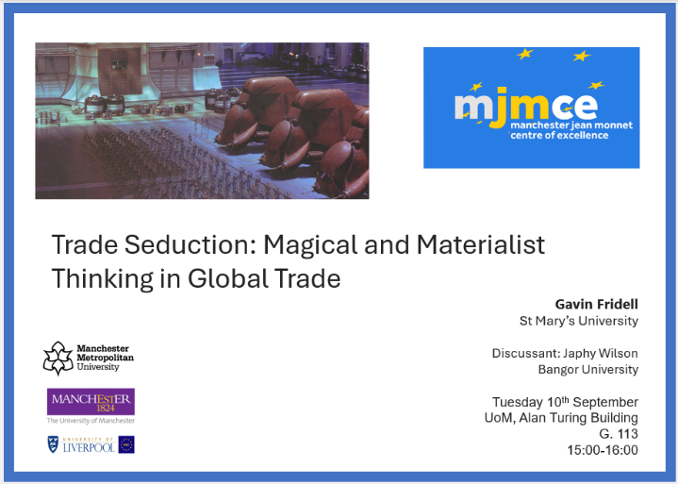
Semester I

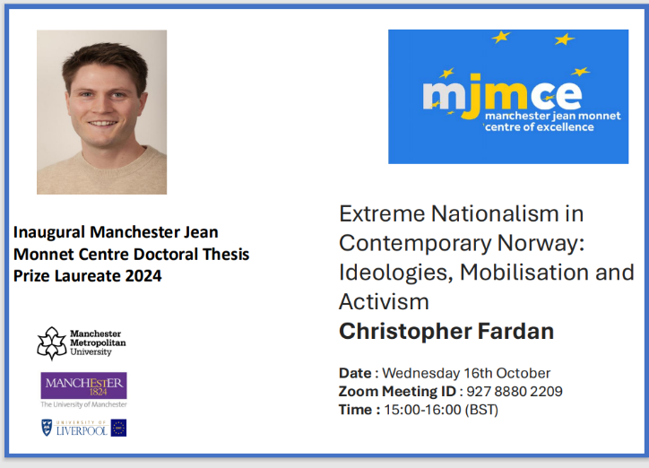

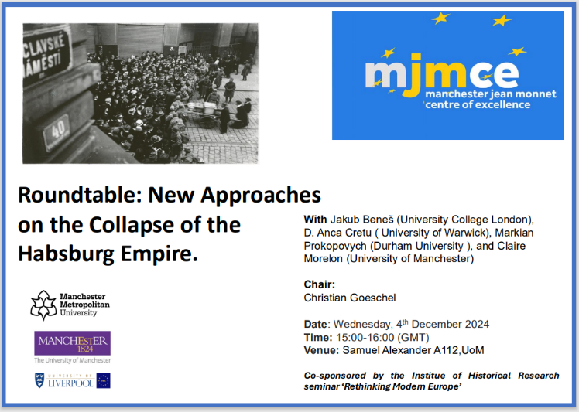

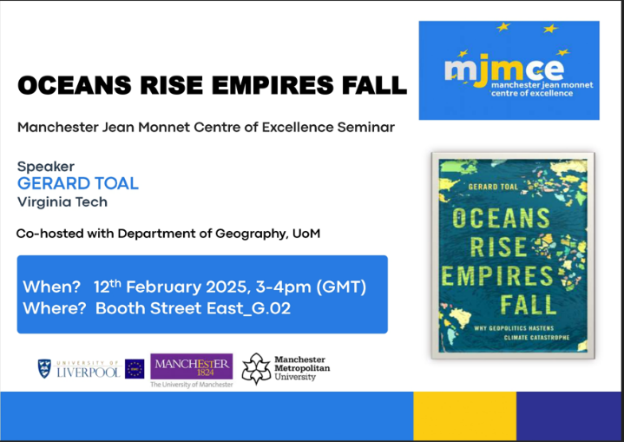

Semester II

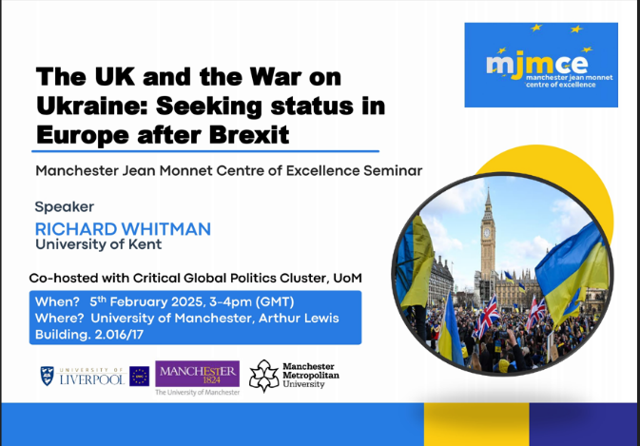

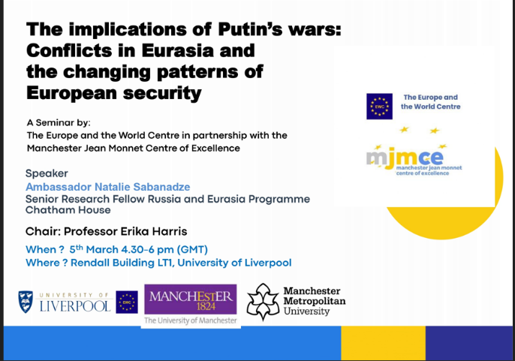

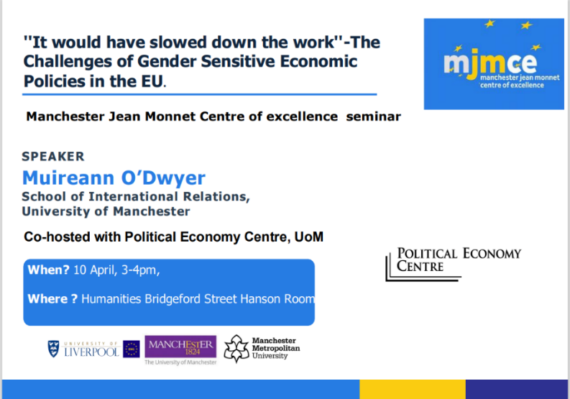
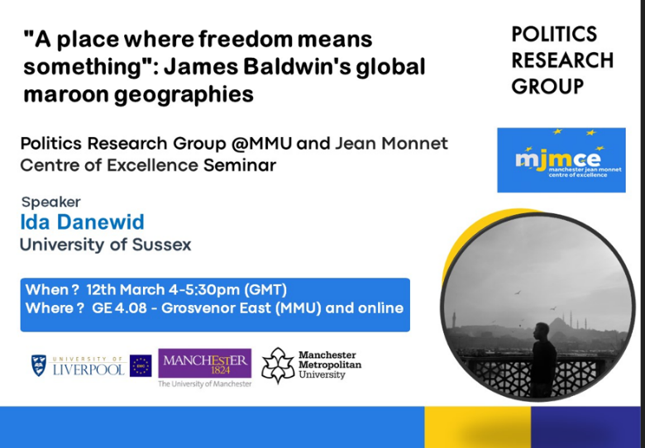

  - MJMCE PhD Conference
The MJMCE held its first PhD Conference in the post-COVID era in June 2025. The conference was organised with the help of a committee of PhD volunteers from SoSS (Politics) and SALC (Italian Studies) at UoM. PhD Volunteers were in charge of setting the conference theme – Reimagining Europe – and composed the call. The conference consisted of a publishing roundtable held with editors of leading journals across the Social Sciences (see poster below) and the roundtable was open to PhD conference participants as well as ERCs and other interested colleagues from all member institutions.

On day 2, we held the workshops featuring 3 panels on “Governing Europe”, “Art, Culture and Politics in Europe” and “Making and Remaking European Identities”. PhD Candidates from member institutions actively participated in the workshop which also attracted participants from abroad. We also had excellent discussants and are grateful to colleagues from UoM (SoSS, SALC, AMBS), MMU and UoL who took on this task!
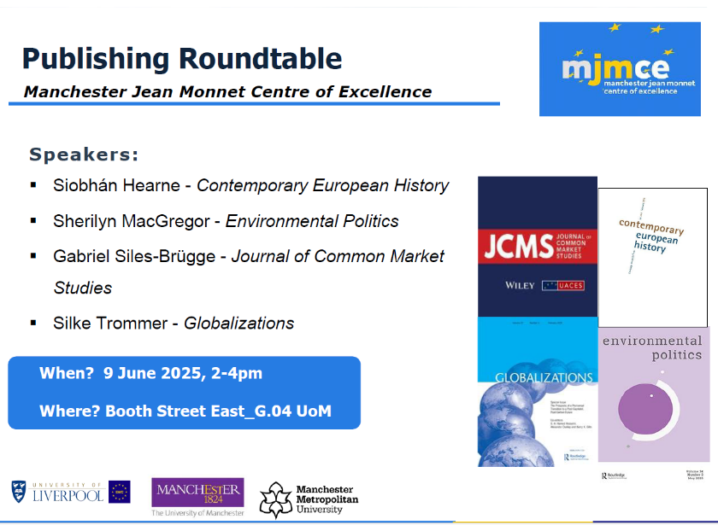

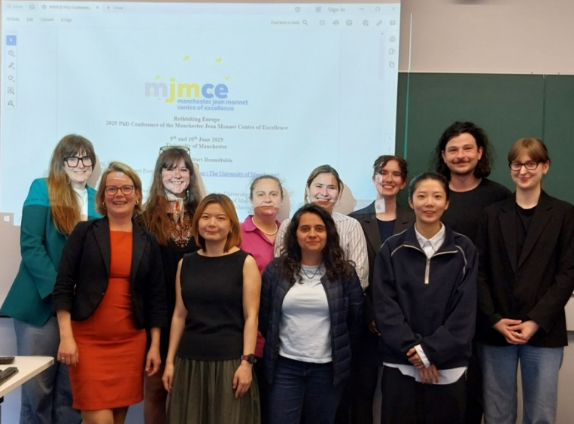
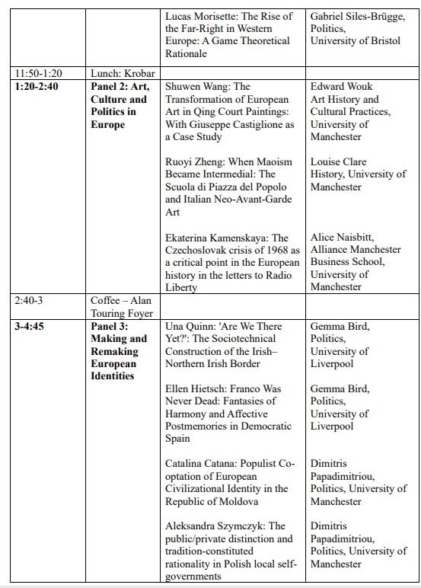
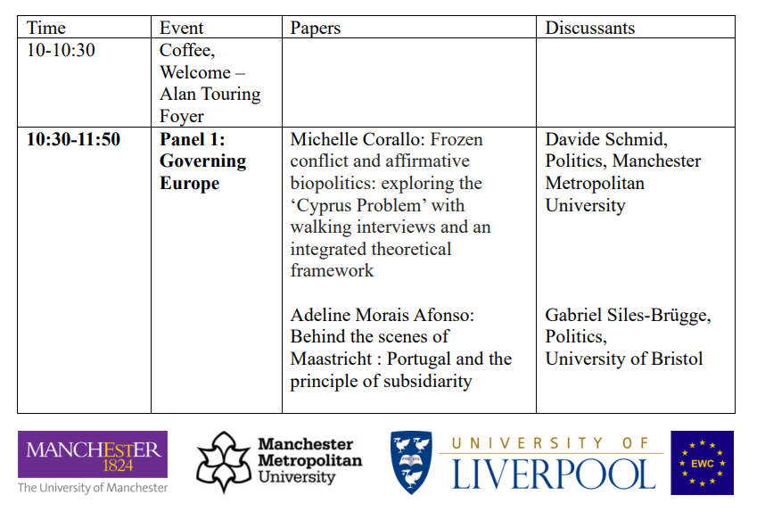

  - Public and Policy outreach

Annual lecture – Public Roundtable Discussion with EU Representatives
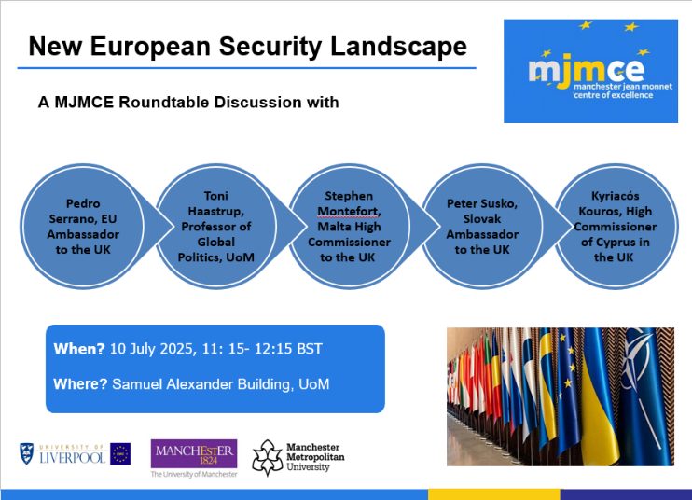
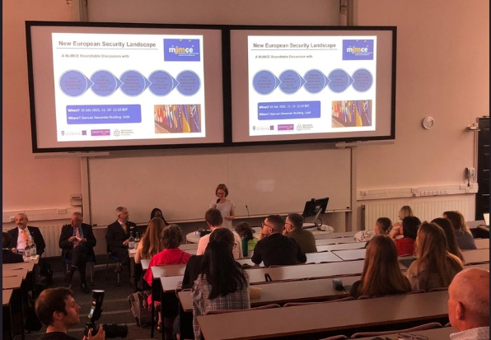
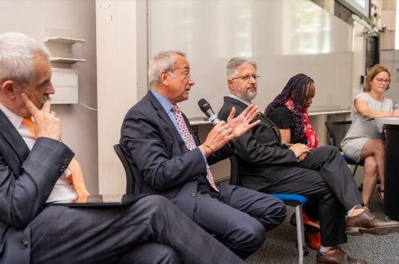
On 10 July 2025, the MJMCE organised a public roundtable discussion during the official visit of the EU Delegation and EU Member State representatives to Manchester. The Roundtable featured an illustrious panel of high-level diplomats and academics that engaged with a full Samuel Alexander Lecture Hall on questions of European Security. Panellists included EU Ambassador to the UK Pedra Serrano, Ambassador of Slovakia to the UK Peter Susko, Maltese High Commissioner to the UK Stephen Montefort, High Commissioner of Cyprus to the UK Kyriacόs Kouros, University of Manchester Global Politics Professor Toni Haastrup and, as Chair, MJMCE Director Silke Trommer. After introductory remarks on the future of EU-UK security cooperation, the prospects for de-escalating current security tensions, and possibilities for promoting human security approaches in times of heightened military investment, the Chair opened the floor to a 150 strong audience made up of students, staff and external guests from local, national and international politics. The audience presented a barrage of questions and panellists regretted that their tight schedule did not allow them to extend the lively conversation beyond the allotted time. Feedback from panellists and audience members alike was highly positive and underscored the fact that the event will remain a highlight among the MJCME’s public outreach activities for years to come.

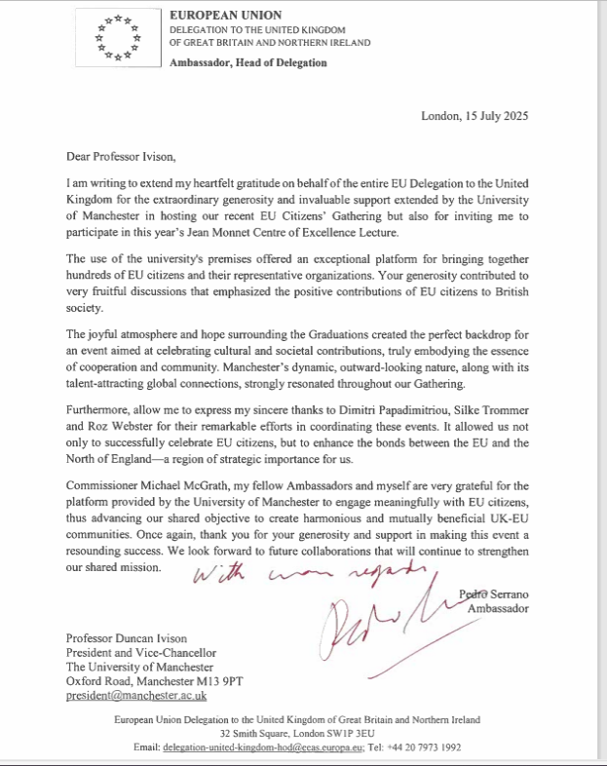
The EU Ambassador to the UK wrote a letter to show his appreciation, in which he mentioned the MJMCE lecture and thanked the MJMCE specifically!

At the time of drafting the report, the UoM communications team is still working on a press release for internal and external communications.

Italian Citizenship Law – information event
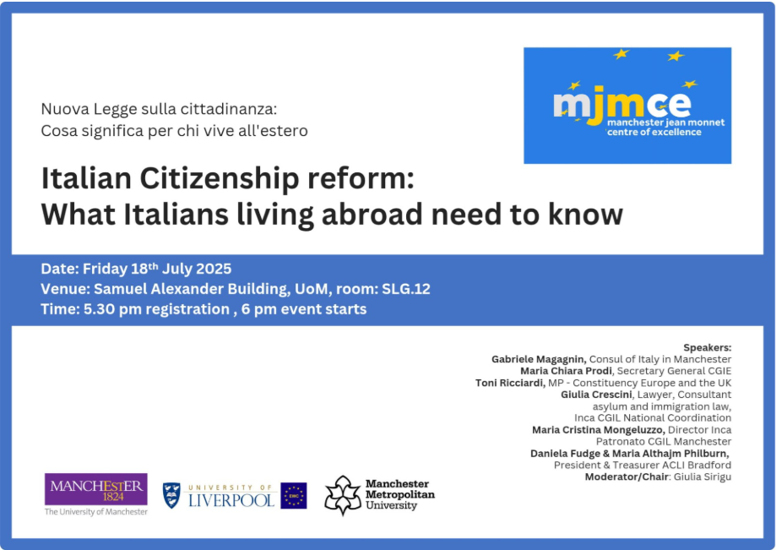
On 18 July, the MJME collaborated with the National Association of Partisans in Italy (ANPI) and several UK and Italian based institutions and volunteer associations, an information event that discussed the implications of legislative changes to the new Italian citizenship law.
The event included a panel discussion featuring Italian institutional representatives, lawmakers involved in the drafting of the reform, support organisations working directly with applicants and members of the General Council of Italians Abroad, the advisory body to the Italian Government and Parliament on issues affecting Italians living outside Italy.

  - JMCE sponsored bursaries, workshops and awards

This academic year, we funded the following fieldtrips, workshops and other research activities across our institutional members:

Bursaries

- Social Movements and State Violence: Dialogues of Memory and Solidarity between Europe and the Global South – Lidia Yáñez Lagos (Department of Sociology, UoM)
My research examines how marginalized groups resist police violence to reclaim their right to protest, focusing on the Chile Despertó (Chile woke up) movement of 2019. As part of the activities supported by the Manchester Jean Monnet Centre of Excellence (JMCE) research bursary, I participated in a seminar on social movements (MOVICON) held at the Faculty of Education at the Complutense University of Madrid (UCM) on the 31st of January this year. This event, organized by the Committee on Social Movements of the Spanish Sociology Association, provided a key opportunity to discuss my doctoral research with experts in the field.
During the seminar, I presented a brief overview of my research on the Chile woke up movement and introduced the central arguments of the first analytical chapter about solidarity and memories. The discussion that followed was highly engaging, as participants acknowledged the relevance of my study and suggested ways to connect it with theoretical debates in Europe and the United States. Additionally, this exchange led to the coordination of a future academic event: a seminar on solidarity and care, which we are planning to hold in May 2025. This seminar aims to bring together scholars and social actors from both Chile and Spain to explore these themes in greater depth.
The JMCE bursary played a crucial role in facilitating my participation in this seminar, allowing me to refine my theoretical framework by engaging with scholars specializing in political contention, solidarity, and collective action. In addition to the perspectives of Spanish colleagues, contributions from doctoral researchers from Argentina, Uruguay, Chile, and Brazil enriched the discussion by deepening the analysis of political violence in Latin America. These exchanges provided a broader regional perspective on state repression and resistance dynamics, strengthening the comparative dimension of my work.
This experience not only contributed to the development of my research but also fostered meaningful academic collaborations that will continue through the upcoming seminar in May and other future initiatives.
Website: https://ucm.es/movicon/seminario
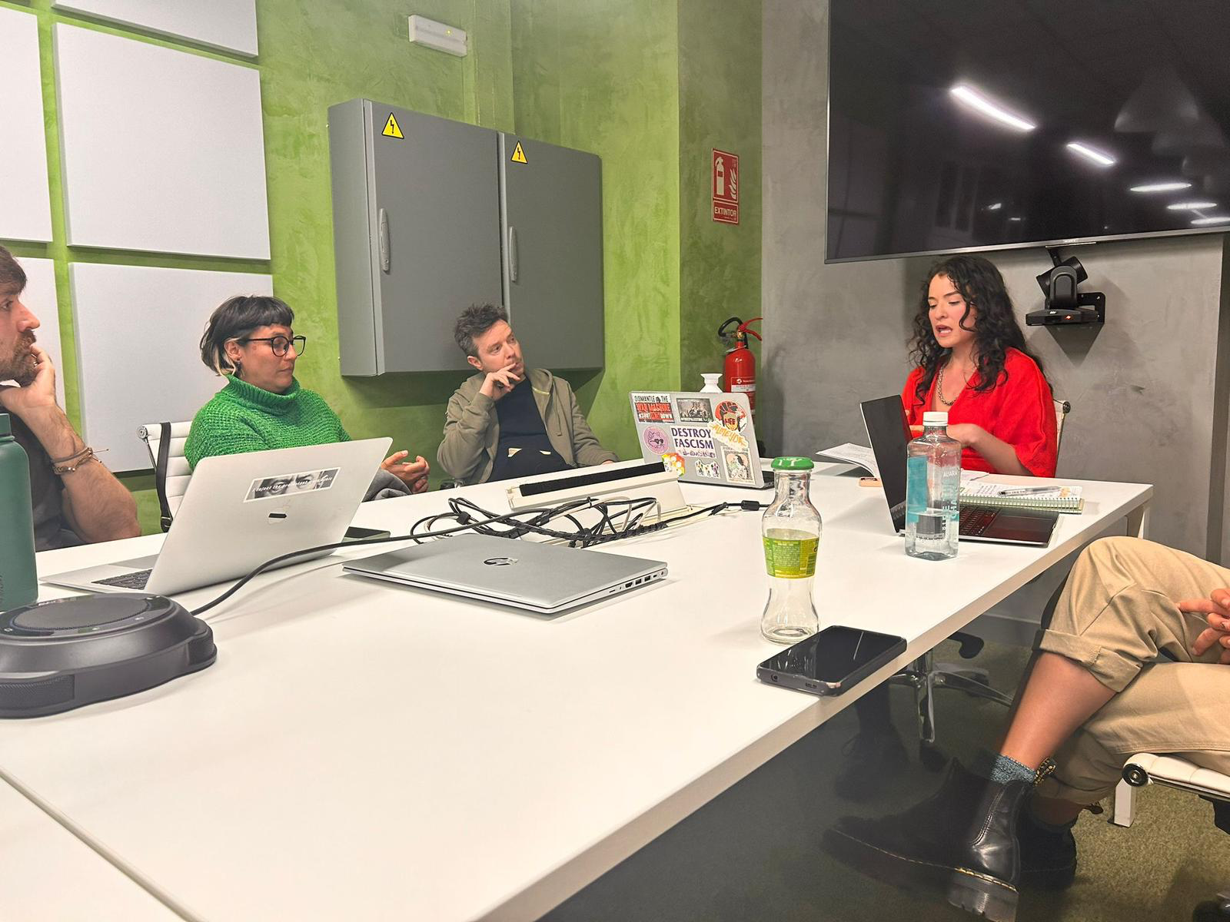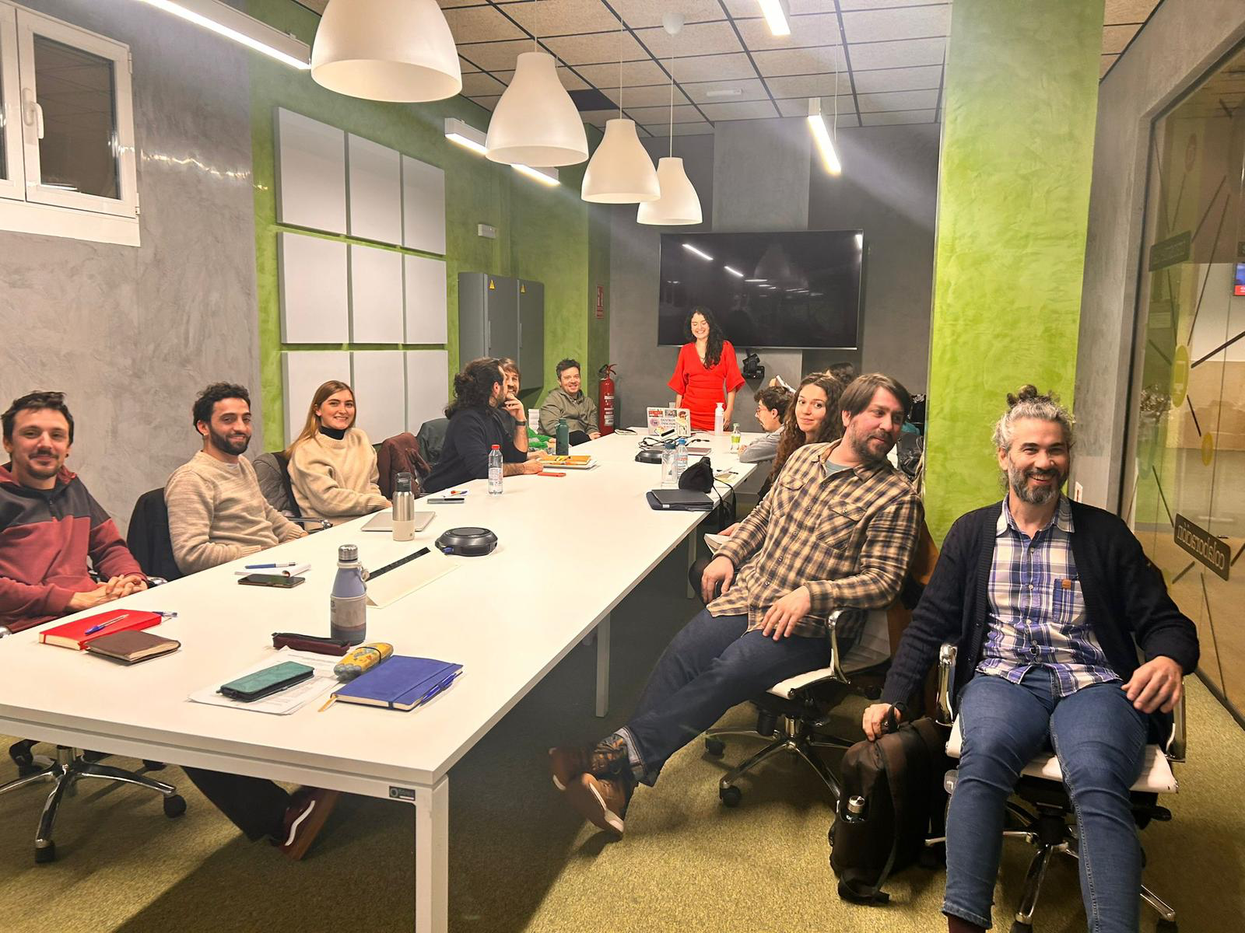

- Harbouring Refugees, Allied with Nazis: Japan's Multifaceted Relations with Germany During WWII - Niamh Hanrahan (Humanitarian and Conflict Response Institute, UoM)

- Humanitarian action, solidarity and migration: Entanglements in the humanitarian space of Greece - Roza Ioanna Sarakatsanou (Humanitarian and Conflict Response Institute, UoM)

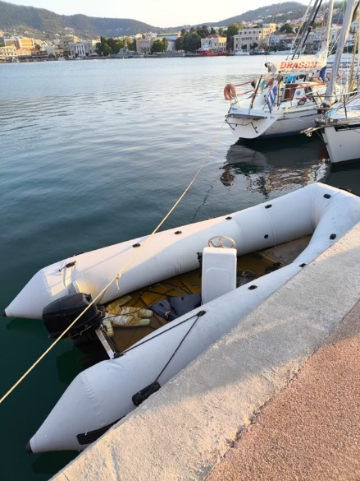
The MJMCE bursary provided essential support for the final three months of ethnographic fieldwork on Lesvos, Greece, conducted as part of my second-year PhD research in Humanitarianism and Conflict Resolution at the University of Manchester's Humanitarian and Conflict Response Institute (HCRI).
During this period, I conducted ethnographic observations across multiple humanitarian sites on the island, examining how different actors navigate and negotiate humanitarian space. The fieldwork revealed tensions between proclaimed openness and spatial arrangements that reproduce boundaries, while also documenting moments where marginalised groups challenge prescribed arrangements and claim visibility. In addition, conducting fieldwork in a moment of aftermath of the so-called “migration crisis”, provided me with the opportunity to reflect on how participants understand crisis not as exceptional moments requiring resolution, but as permanent conditions with predictable rhythms that sustain humanitarian presence.
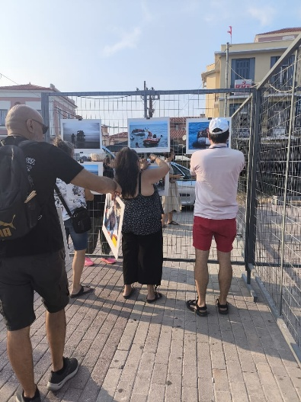
The bursary enabled me to expand my research beyond the main city to include visits to community centers and open sites close to the official camp facility, former camp sites, and key points in rural areas, like the Refugee Cemetery. I conducted conversations with multiple actors, institutional authorities, aid workers, local residents, and people that had to navigate the legal route of refuge and asylum processes.
This first photo, was taken at Mytilene's marina during June, captures a leftover dinghy positioned alongside sailboats used by tourists, with Greek coast guard vessels visible in the background.

The second photo was taken during World Refugee Day events (June 20th) in the island's central square, showing participants setting up a photo exhibition featuring images from the more intense moments of the refugee crisis during 2015-2016, particularly depicting people along migration routes through the Aegean Sea and Balkan borders.
- The alignment of the constitutional value space in Scotland – Marta Miori (Department of Politics, UoM)

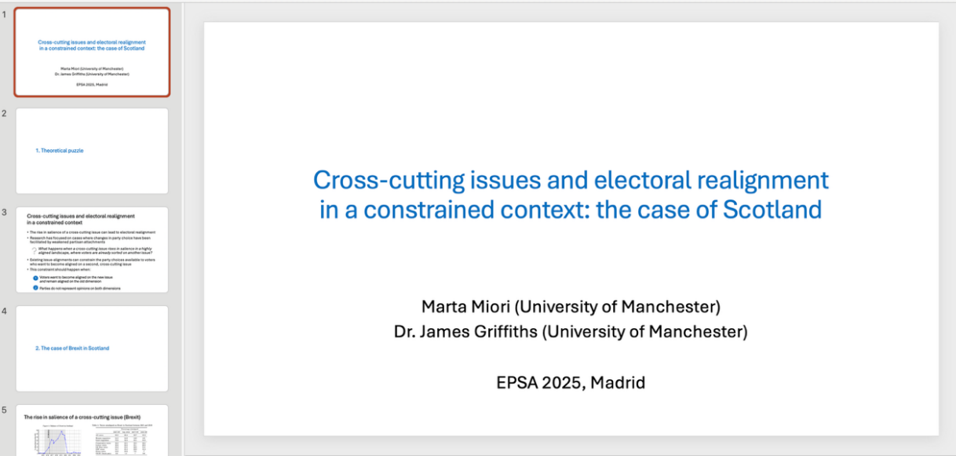
Thanks to JMCE funding, I travelled to Madrid for EPSA’s annual conference where I presented a paper on Brexit and independence in Scotland – specifically, how the electoral consequences of voter cross-pressure on the question of EU membership can be mitigated by voters holding other sub-national constitutional positions that tie them to their political party. It was a memorable and incredibly beneficial experience: I received some very helpful feedback on my work, gained some new perspectives on how my case study can be relevant to other national contexts, and met a few researchers whose work I had been reading for a very long time. I would not have been able to go without the JMCE funding, so I am very grateful!

- Media Strategies of the Russian Opposition in Exile: Political Influence and European Narratives - Aleksei Chumakov (Department of Politics, UoM)

- Guardians of Humanity: Justifying Nuclear Possession – Zeenat Sabur (Department of Politics, UoM)

The MJMCE bursary supported my recent attendance at BISA’s annual conference in Belfast. While attending the conference I engaged in activities that supported my professional development and thesis. Firstly, I presented a paper that is a chapter of my thesis. The feedback will feed into the chapter’s final iteration. I am a fellow at the University of Glasgow on the Atomic Anxiety in the New Nuclear Age programme Fellow [atomicanxiety.com]ship and at BISA I was able to meet and connect with other members of this programme. I was also able to develop ideas for journal articles, as a result of various panels and conversations.

Workshops
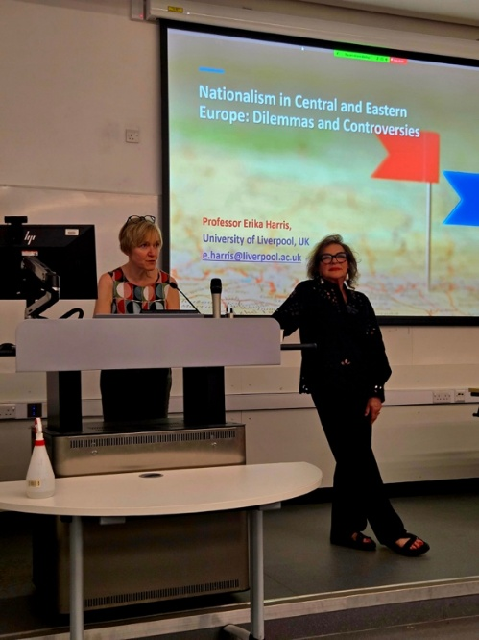
- European nationalism resurgent in the 21st century - Dr Mate Subasic, Dr Gemma Bird, Dr Hannes Baumann (Europe and the World Centre, UoL)
At the beginning of the 21st century, European nationalism was treated as something that happened at the margins of the continent, spilling into violence in Southeastern Europe or the post-Soviet space, or that happened beyond Europe, for instance in the Middle East or Africa. This was despite warnings that “banal” nationalism in Europe had the potential of turning “hot”. Since then, we have seen the resurgence of far-right populism, nativism or even national populism in Central and Eastern Europe. This is therefore an urgent moment to revisit theories of nationalism.
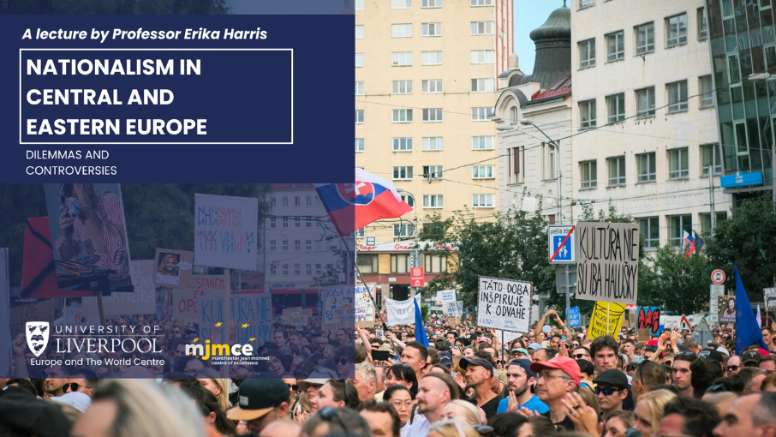
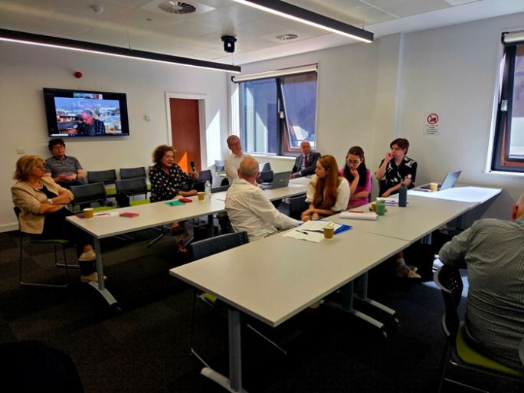
Our public lecture and one-day workshop at the University of Liverpool in May 2025 re-evaluated scholarship on nationalism over the past thirty years to throw new light onto the resurgence of European nationalism in the twenty first century. The workshop was based on the work of Professor Erika Harris, University of Liverpool, over the past thirty years. She holds the Bowes Chair in Politics and is internationally recognized as an expert on studies of nations and nationalism generally, but specifically in Central Europe, post- Soviet space and the Balkans. Professor Harris held a public lecture at the University of Liverpool titled “Nationalism in Central and Eastern Europe: dilemmas and controversies”. It was based on her forthcoming book published by Bristol University Press. The lecture drew an audience of several dozen academics, students and members of the public. The MJMCE funding enabled staff and students from Manchester to join us on the night.
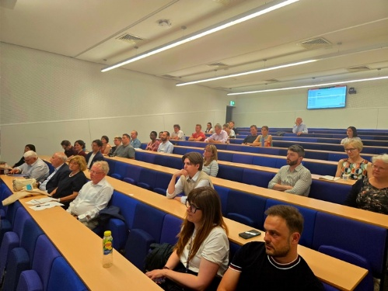
The workshop brought together scholars based in Australia, Croatia, Hungary, Israel/Palestine, Slovakia, and the UK: Professor Dejan Jović, Professor Richard Gillespie, Professor Erika Harris, Professor Silvia Miháliková, Dr Michiel Piersma, Professor István Pogany, Dr John Schwartzmantel, Dr Mate Subašić, and Professor Oren Yiftachel. Topics included a theoretical re-evaluation of nationalism studies based on Professor Harris’ contribution, the relation of urbanism and neo-nationalism, the role of area studies in nationalism research, and case studies from the Romanian-Hungarian border, Slovakia, Catalonia, and Croatia.
We are approaching Liverpool University Press to publish the papers presented at the workshop into an edited volume.

- Researching and Writing Contemporary European History - Dr Siobhán Hearne (Department of History, UoM)
On 13th June 2025, I hosted the workshop ‘Researching and Writing Contemporary European History’, which was generously funded by the Manchester Jean Monnet Centre of Excellence. The event brought together postgraduates, early career researchers, and established scholars to discuss sources and methods for researching contemporary European history, as well as how best to communicate our findings to a broader audience. The morning sessions included a keynote lecture from Dr Daniel Laqua and a roundtable on methodologies with Professor Dominique Reill, Dr Jo Laycock, and Dr Laure Humbert. The afternoon was dedicated to supporting postgraduates and early career researchers. For this, we hosted a roundtable on publishing in academic journals with the editors of Contemporary European History and History, after which we ran small-group sessions in which participants could receive feedback on draft articles. Overall, the event brought together a wide range of Europeanists and offered important development opportunities for PGRs and ECRs.

- Global Trajectories of Soviet Nationalities Policies and their Aftermath: Federalism, Identity, and Revolution, 1917-2022” - Dr Roy Bar Sadeh (Department of History, UoM)
Please find below a brief report on the international workshop I recently co-organized, titled Global Trajectories of Soviet Nationalities Policies: Federalism, Identity, and Revolution, held at the University of Manchester on 9–10 June 2025 (Room A114, Samuel Alexander Building).This event—co-sponsored by the University of Manchester’s School of Arts, Languages and Cultures, the Manchester China Institute, and the Manchester Jean Monnet Centre of Excellence—brought together leading historians from the UK and abroad to examine the global history and enduring legacies of Soviet nationalities policies. The full program is attached for reference. In light of ongoing geopolitical developments—not least the war in Ukraine—there has been renewed scholarly interest in how the Soviet Union approached ethnic and religious diversity. While domestic aspects of Soviet nationalities policy have been extensively studied, their international ramifications remain comparatively underexplored. This workshop addressed this lacuna, examining how political systems across Asia and Africa were influenced by, responded to, or reinterpreted Soviet approaches to managing difference. In turn, it asked how the USSR itself was shaped by its international entanglements.
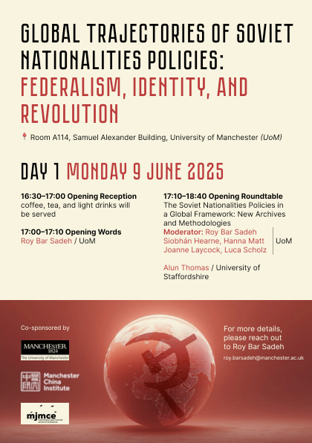
Among the central questions we explored:
- Was nationality-based federalism a Soviet export?
- In which contexts was it adopted, adapted, or resisted?
- What can this tell us about broader patterns of nationalism, separatism, irredentism, and multiethnic governance in the 20th century?
By engaging these issues, the workshop aimed to develop a fresh framework for understanding the Soviet Union and the Global South as historically interconnected—challenging dominant Euro- and US-centric narratives of modern state formation and minority rights.
We were pleased to welcome approximately 35–40 participants across various panels and roundtables, creating a lively and productive scholarly exchange. I’m also excited to report that two special peer-reviewed journal issues are already in their conceptualization stage:
- A region-specific issue on Asia, which I will co-edit with Dr. Aaron Glasserman (University of Pennsylvania) and contribute to, to be submitted to the Journal of Asian Studies (flagship journal of the American Association for Asian Studies; publication expected in 2027).
- A issue on the global history of Soviet nationalities policies in the Global South, which I will co-edit with Prof. Masha Kirasirova (NYUAD), to be submitted to the Journal of Comparative Studies of South Asia, Africa, and the Middle East (Duke University Press; also expected in 2027).
Looking ahead, I’m beginning to shape a proposal for an AHRC funding scheme around these themes. The workshop made clear that we've only scratched the surface of what is a major, underexplored topic.

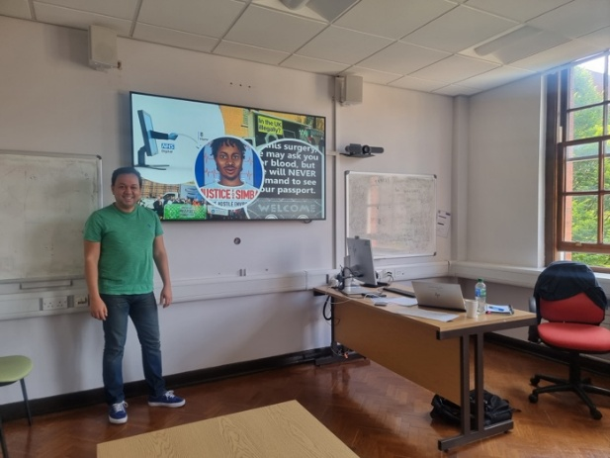
- Healthcare provision for migrants: making the case for more hospitable health systems in the UK and across Europe - Dr Sabah Boufkhed (Humanitarian and Conflict Response Institute, UoM) & Dr Moises Vieira (Department of Politics, UoM)
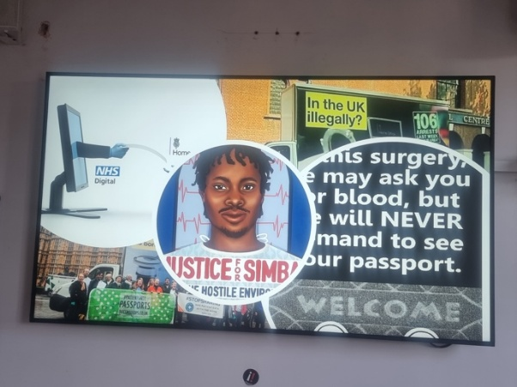
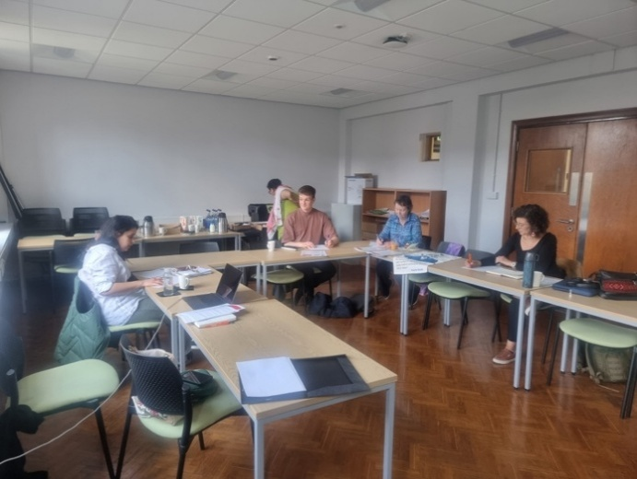
In the workshop, participants reflected on bordering processes in the National Health Service in England and their links to the hostile environment for migrants in the UK. Discussions focused on how healthcare provision can work to welcome migrants into the country while enhancing their health and wellbeing. Participants explored how immigration enforcement in the NHS has undermined hospitality and promoted hostility in spaces of healthcare. Together, attendees developed the draft for a co-authored commentary piece, currently in progress, which captures key insights from the session. The group also agreed to establish an ongoing network to support continued dialogue, collaborative writing, knowledge sharing and the organisation of future events centred on healthcare and migrant justice.

- Shifting Conceptualisations of ‘Europe’ among the Far Right - Dr Nicola Mathieson (Department of Politics, UoL)

On the 30th of April, 2025, the School of Histories, Languages and Cultures at the University of Liverpool had the pleasure to host Dr Ashton Kingdon (University of Southampton) and Dr Catherine Tebaldi (University for Luxembourg) for a workshop on Shifting Conceptualisations of ‘Europe’ among the Far Right. The event, organised by the Global Far Right Studies Network, sought to explore the shifting nature of how far right actors globally conceptualise and connect to Europe and European Identities. The workshop generated discussions around recognizing far-right content (especially in tradwife content), the explicit bias embedded in AI, and the gendered divide in the production of far-right content.
- The Almanac, the Annual, and the Pocket Book: Origins, Evolutions, and Intersections - Dr Sonja Lawrenson (Department of English, MMU)

Awards

Master’s Dissertation Prize
Winner of the Manchester Jean Monnet Centre of Excellence Master’s Dissertation Prize Announced

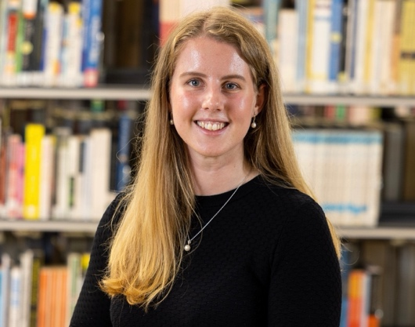
We are delighted to announce the winner of the MJMCE Master’s Dissertation Prize for 2023/24, which recognises and celebrates the excellent research produced by Master's students in the area of European Studies. The winner of the prize is Sophie Stanford for a project titled 'Socialist Solidarity or Self-Interest?: The Impact of the Vietnam War on Romanian-American Bilateral Relations During the 1960s’. Sophie’s dissertation, which was completed as part of the MA degree in History at the University of Manchester, examined the impact of the Vietnam War on Romanian-United States relations during the 1960s.
In accepting the award, Sophie Stanford said:
“My dissertation explores how three key events during the Vietnam War – the Gulf of Tonkin incident (1964), Operation Rolling Thunder (1965–68), and revelations of the My Lai massacre (1969) – were received in Romania. I evaluate whether self-interest, in the form of the development of economic and bilateral relations with the United States, or socialist solidarity with Vietnam was most significant in mediating the Romanian Communist Party’s response to the conflict. Through analysis of Radio Free Europe reports, and Romanian newspapers, I reveal that while the Party’s response to the conflict fluctuated, by the turn of the decade, self-interest in the form of economic cooperation with the United States outweighed socialist solidarity with Vietnam.
I chose to explore this topic, as I wanted to understand how foreign policy considerations shaped responses to atrocities during the Cold War. In doing so, I have provided a valuable contribution to the scholarship by highlighting the role interactions between domestic considerations and geopolitics played in shaping Romanian responses to atrocities during the Vietnam War.”

Doctoral Thesis Prize
Winner of the MJMCE Doctoral Thesis Prize Announced
We are delighted to announce the winner of the second MJMCE Doctoral Thesis Prize, which recognises and celebrates excellent research produced by doctoral researchers on matters related to European history, politics, culture and languages. The winner of the 2024/25 prize is Dr Sarah Elmammeri for her thesis titled ‘Trapped between Borders: Constructing a Multi-perspective Approach to Bordering Practices in the EU between the International, Regional and National Layers’. Dr Elmammeri completed a PhD in Politics at the University of Liverpool in 2024. The judges found this project to be especially notable for the urgency and relevance of the topic, the empirical depth and richness of the material, and the sophisticated analysis through which it contributes to critical border studies and postcolonial understandings of the so-called European refugee ‘crisis’.

In accepting the award, Dr Elmammeri said: “My doctoral thesis investigates the multiplicity of bordering practices in the aftermath of the 2015–2016 so-called refugee ‘crisis’. The research employs a multi-layered analytical framework to examine bordering processes across three levels: international, regional, and national, using European Commission policy documents alongside 21 semi-structured interviews conducted in English and Arabic with NGO workers, asylum seekers, refugees, and volunteers in the UK. At the time of the research, the UK was still part of the European Union and was treated as an EU member state. It also served as a destination country for many of the participants involved.
The thesis highlights the need to conceptualise borders not only as territorial demarcations, but as complex and dynamic systems shaped by both physical and non-physical, visible and invisible forces. These systems are constructed and maintained by both political and non-political actors and often reflect colonial legacies and hierarchies. By tracing the lived experiences of asylum seekers and refugees, the thesis proposes a holistic perspective on how bordering practices are produced through policy and challenged through the knowledge and experiences of my participants. This project emerged from a combination of personal experience and academic inquiry. As someone who has personally encountered the complexities and limitations imposed by borders, I have long been interested in how these borders are constructed, experienced, and challenged. The 2015–2016 so-called refugee ‘crisis’ and the EU’s political reaction to it sparked my academic curiosity about how borders operate through colonial hierarchies.”
Considering the very high standard of the nominations received, the judging committee also decided to award an honourable mention to Dr Kris Kaleta (MMU) for his thesis ‘Beyond the Freedom Line: Analysing Libertarian Digital Community in Poland’.

  - The JMCE-sponsored Book Series on European Politics (MUP)
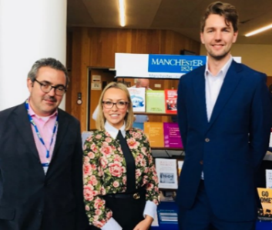
Since 2019 senior members of the JMCE’s Board have teamed up with Manchester University Press to relaunch the European Politics Series. The JMCE is actively sponsoring the series, both in terms of editorial guidance and promotion. It has been a good year for the series, with two new books published and Koen Slootmaekers (who gave an MJMCE seminar on his book in 2022), winning the EUSA best book price 2025!
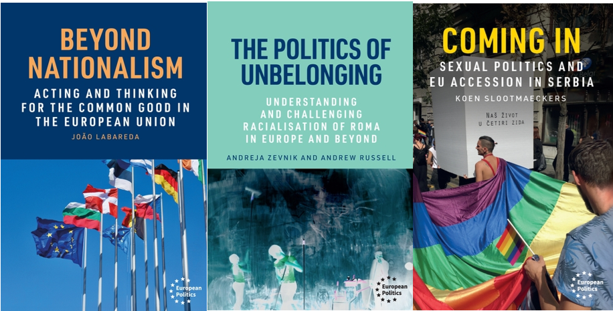
Prof. Papadimitriou, Dr.Simpson and JMCE board member Dr. Tobin are the series editors

For more details visit: https://www.manchesteruniversitypress.co.uk/series/european-politics/
- News

  - The JMCE in the News

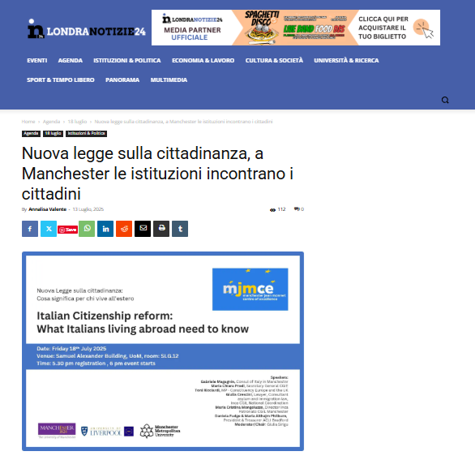
The online newspaper for Italians living in the UK, Londra Notizie 24, reported on the Italian Citizenship event in July.

The headline translates as: “New citizenship law: in Manchester, the institutions meet citizens”

  - JMCE Members in the Media

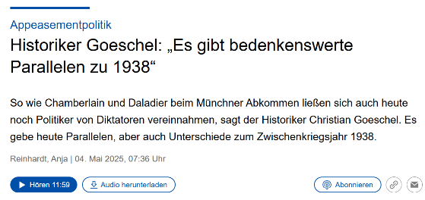
JMCE board member Dr Christian Goeschel (UoM, SALC) has appeared to international streaming, TV and radio audiences to speak about the history of Nazi Germany, including a radio interview on the politics of appeasement and Channel 4 flagship production on the end of World War II.
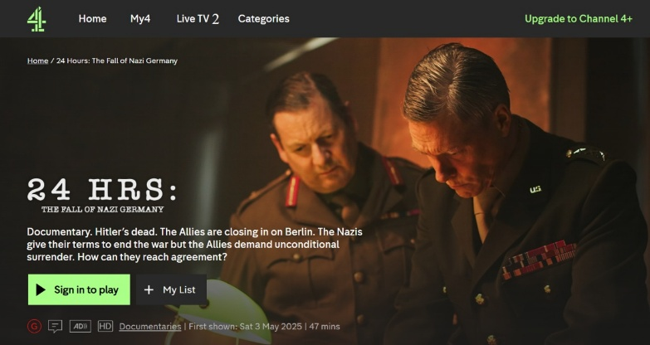

  - Save the Date!

- Summer 2025: Watch out for the press release on the JMCE Annual Lecture!
- September 2025: Watch out for the announcement of the MJMCE UG Dissertation Award Winner 2025 and for the publication of our seminar series and joint events!
- Academic Year 2025/26: Watch out for JMCE-funded Workshops, Postgraduate Research Bursaries and BA, MA and PhD Dissertation Prizes!

